Palace Concert

*Escapism - Musicophilia - Surrealism*

If there is something that all humans share, it is an adoration for music. However, nothing compares to the experience of attending a live concert. Feeling the bass through your body and reciting the song by heart, live music has to be one of humanity’s greatest feats. It brings people together, and for a minuscule moment in time, we are all able to enjoy music together and forget about everything else going on in our chaotic lives. Unfortunately, we are living in unreal circumstances. In a time when we all want to be together, we are forced to be apart in order to keep ourselves and the ones we love safe. We can no longer enjoy the gift and feeling of live music for the time foreseen. We wanted to create a safe virtual space where a patron could enjoy music while curating an experience that gives the user the ability to interact with the virtual world full of interesting sights and sounds. They are able to explore the virtual world, beginning in a dark and uncertain cave and ending in a massive palace ballroom-esque music room. A palace holds an exalted being; typically performers are seen as elevated or exalted. In our palace, there may not be a performer, but the music exists as it’s own being in the space. After being restricted to a path with unfamiliar creatures, treacherous terrains and strange sights and sounds, the player is then free to enjoy the music and the space, an experience adjacent to attending a concert. The goal of our game is to escape a dark cave and find a dance floor; to escape the difficulties of reality and do something a little bit different.

Team Members

Madi - Coordinator, modeling, sound, environmental design

Ashe - Character design, modeling, environmental design, animation

Grayland - Environment design and modeling

Sabrina - Sound

Filipe - Programming mechanics ,environmental design

Video Documentation

<https://drive.google.com/drive/u/1/folders/1uadhJebPeJWSVYmwR6dVUJRFGynFNdRR> (currently unedited)

Environment

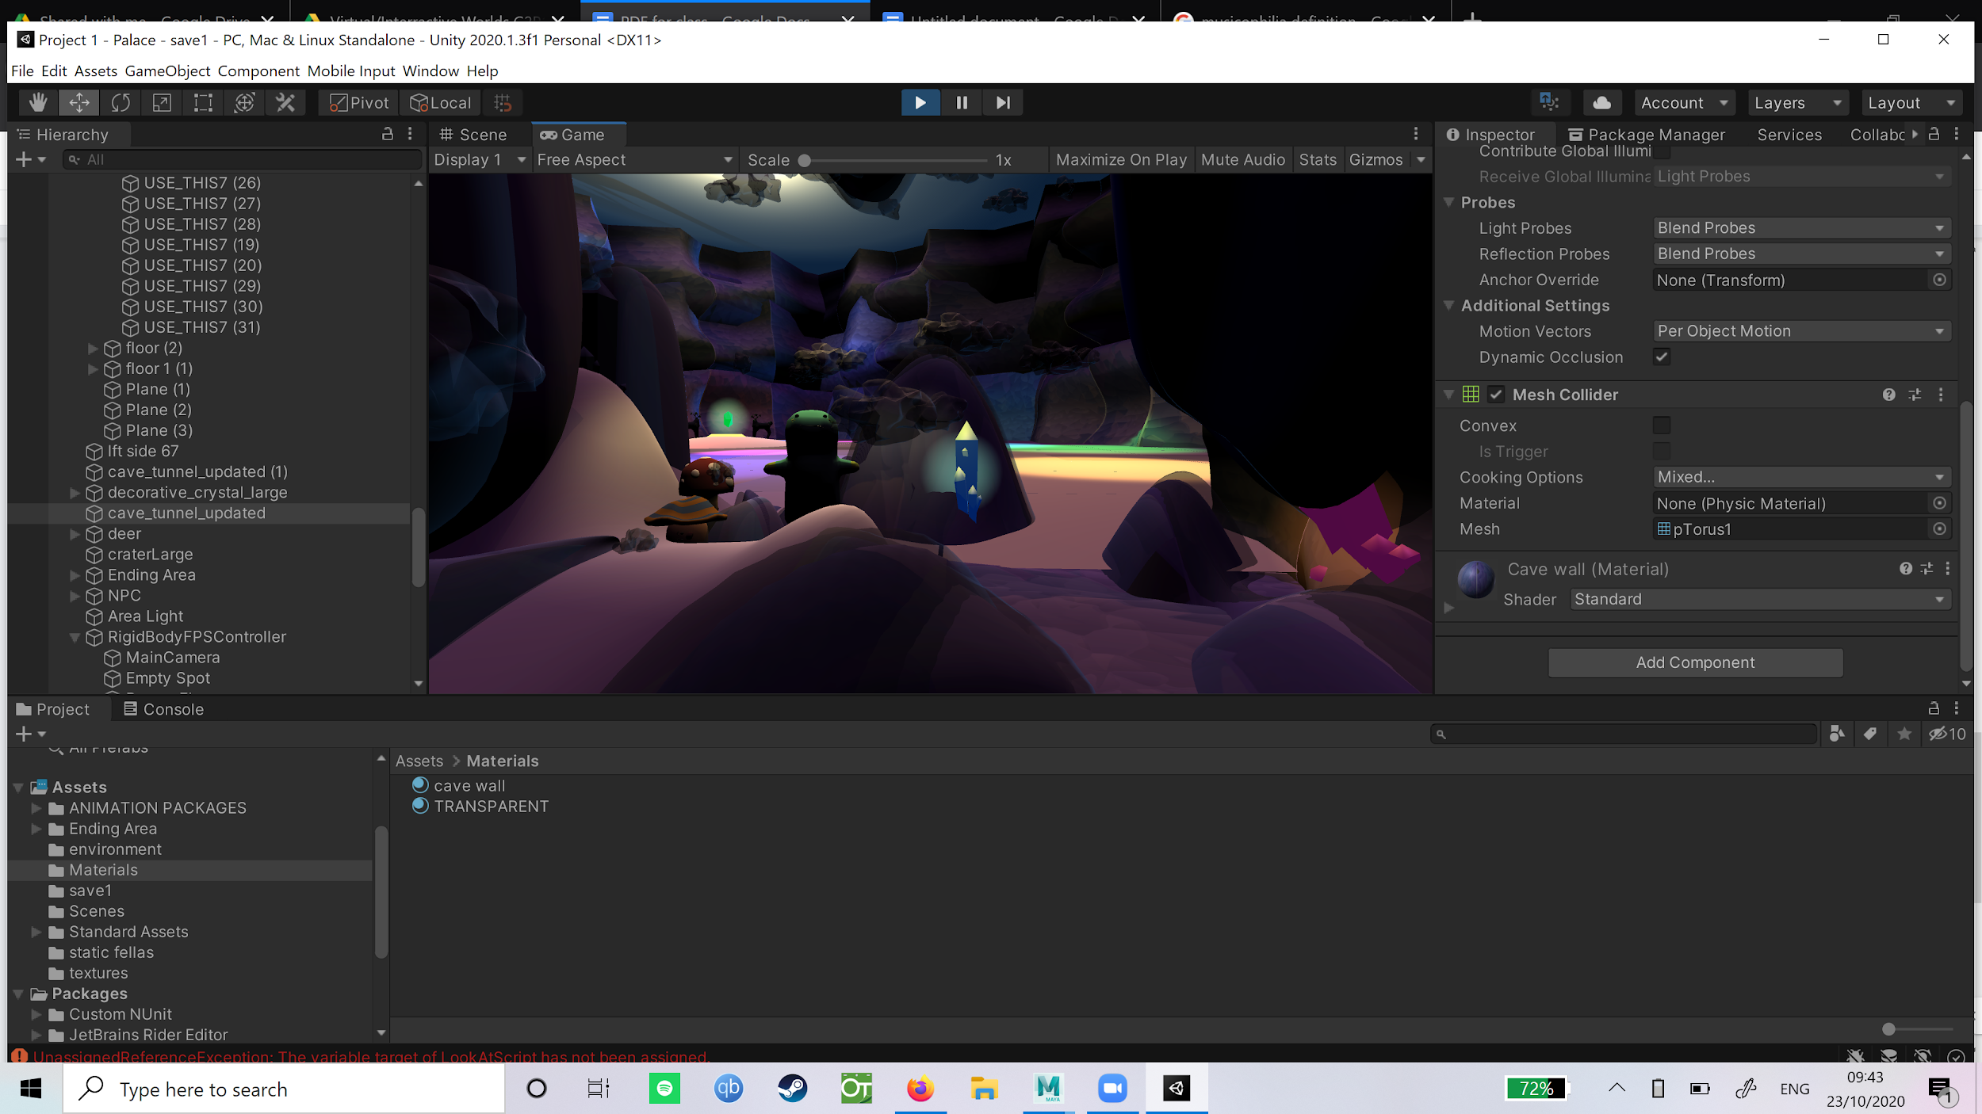

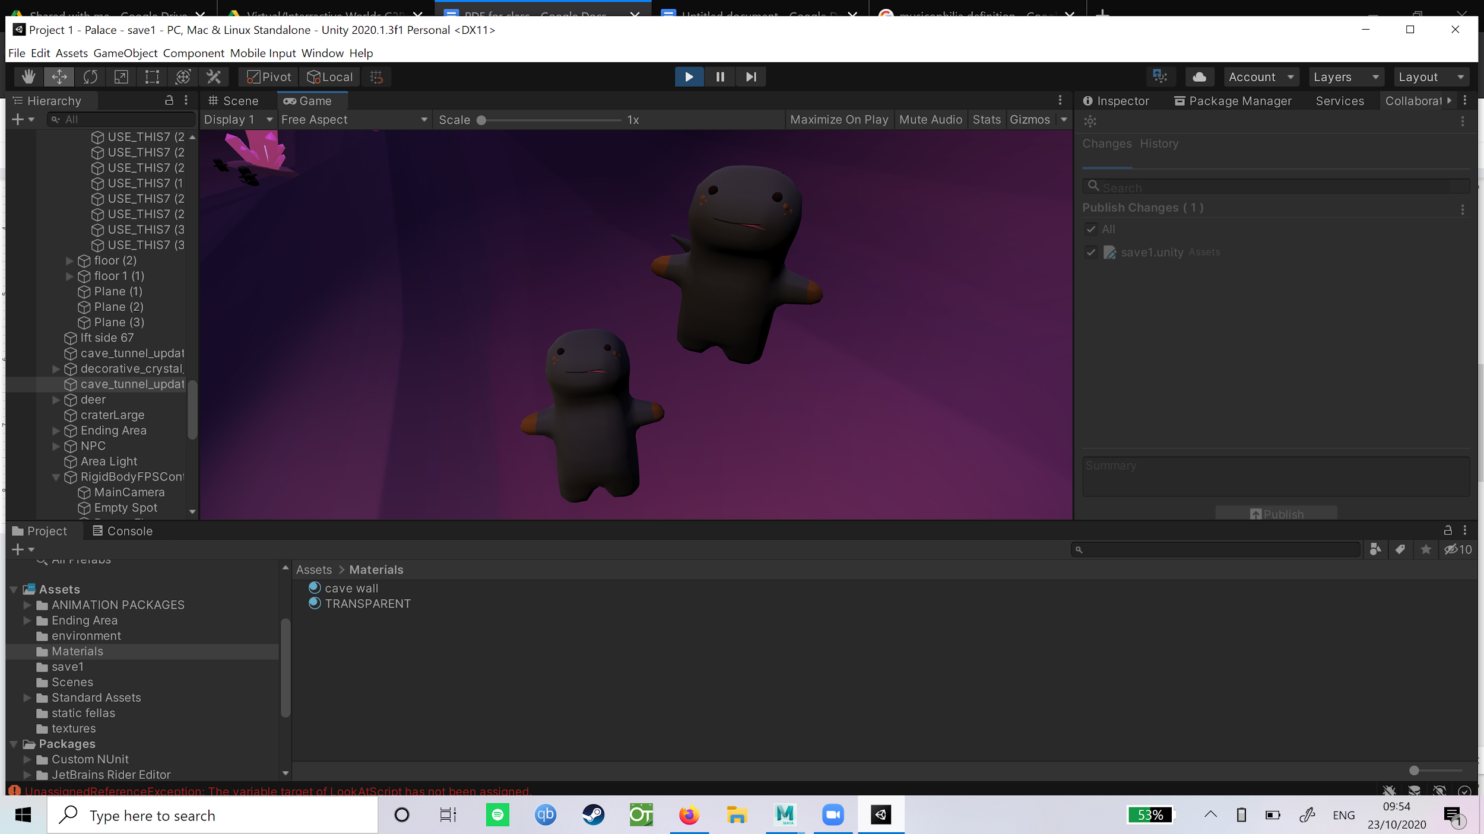

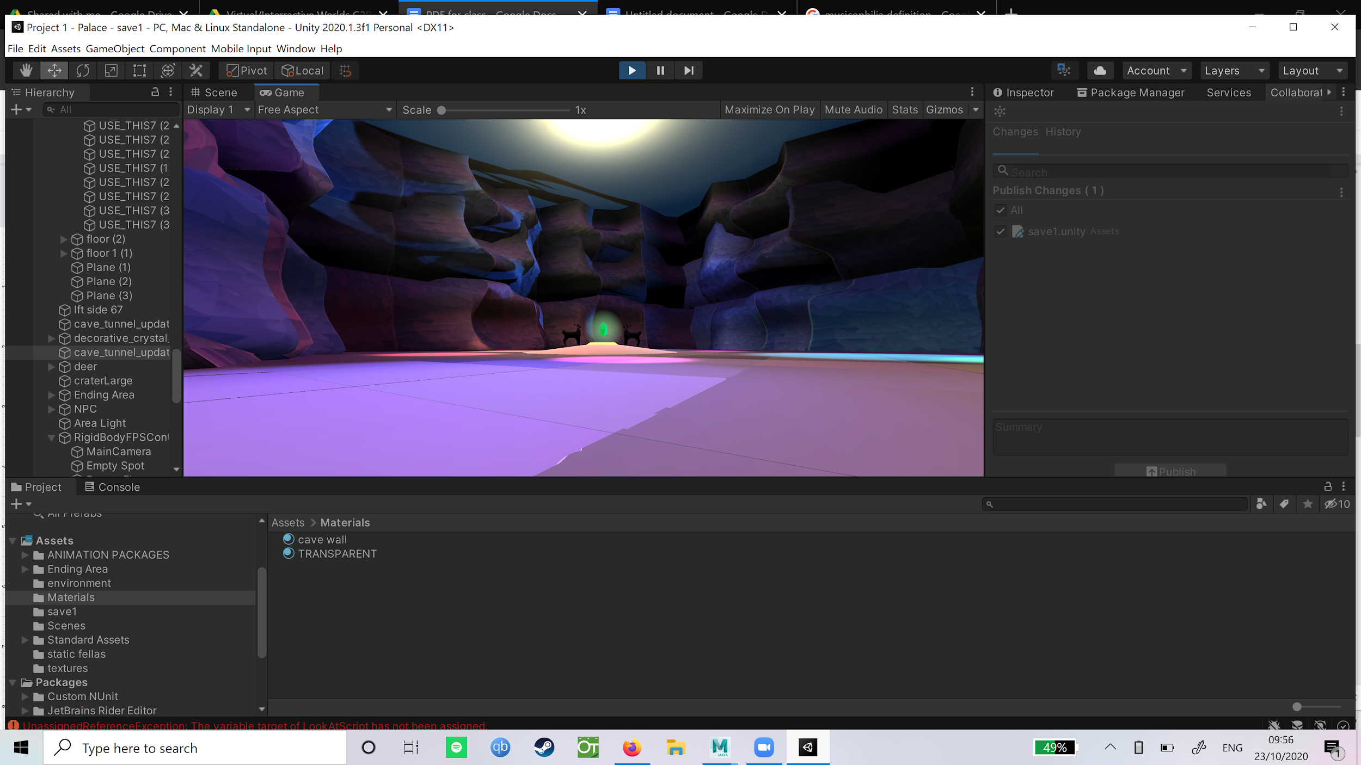

Characters

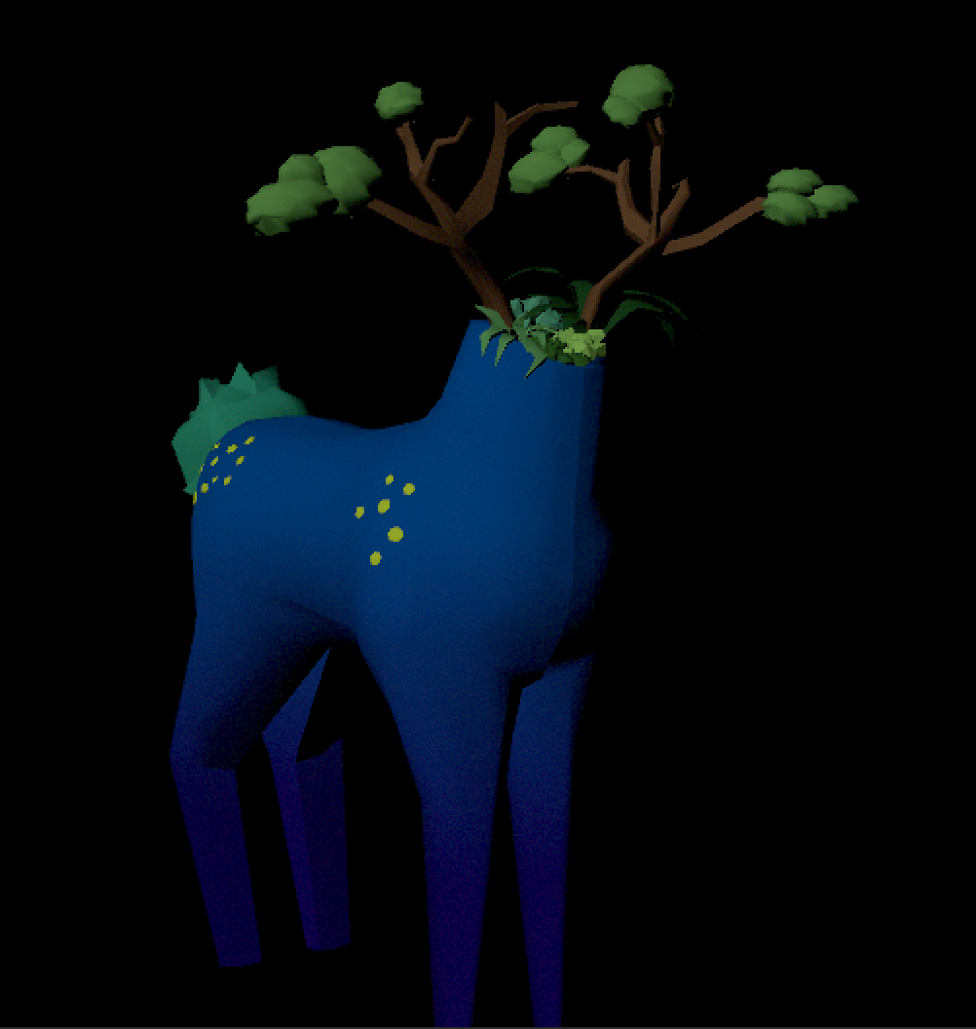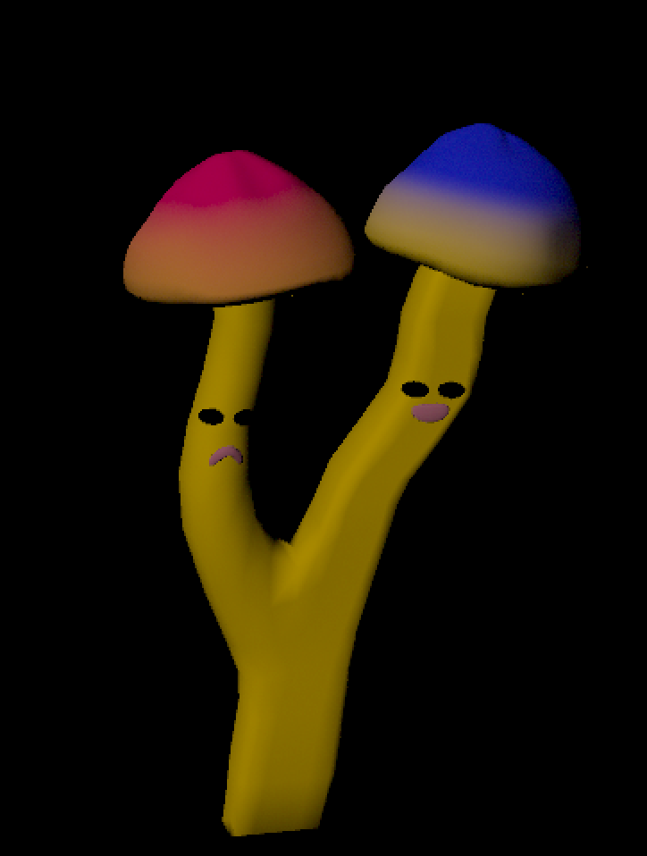

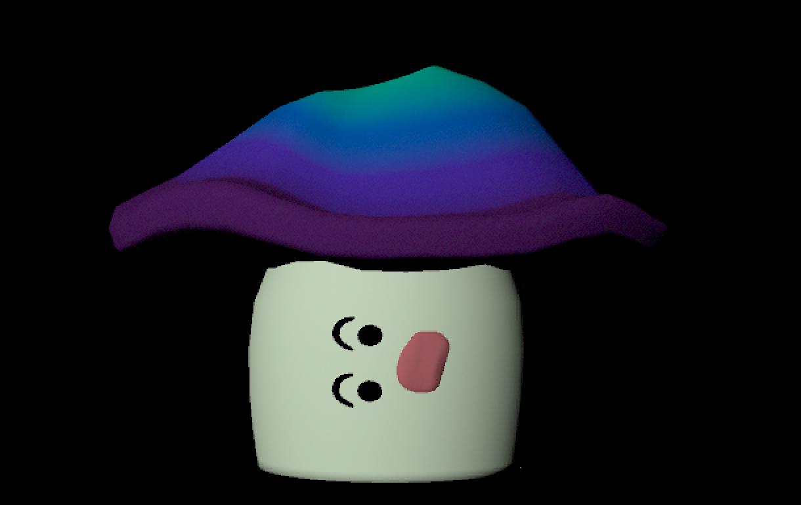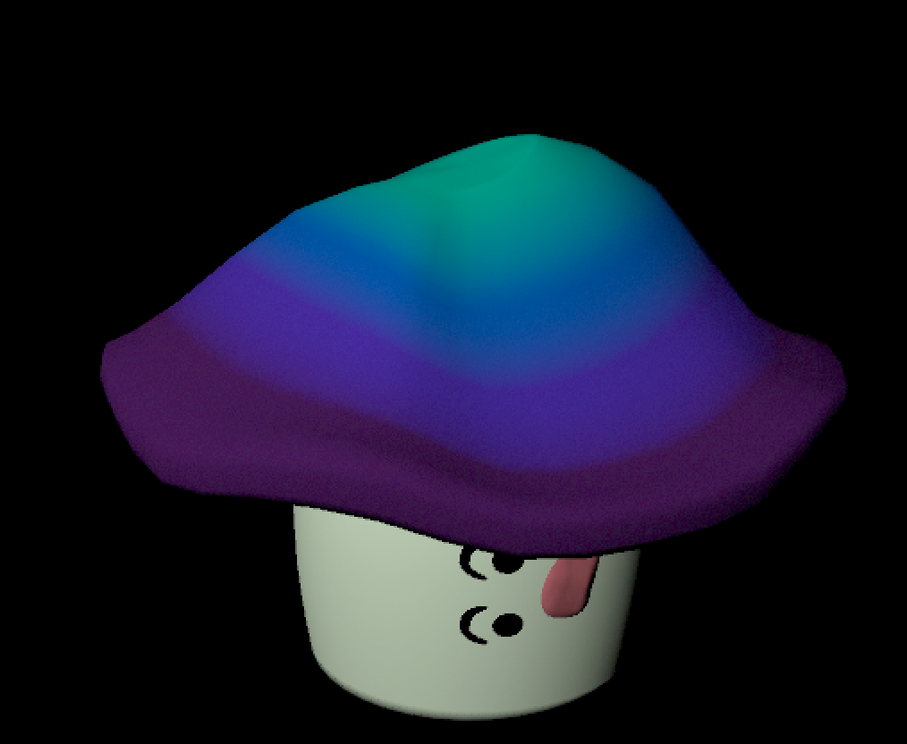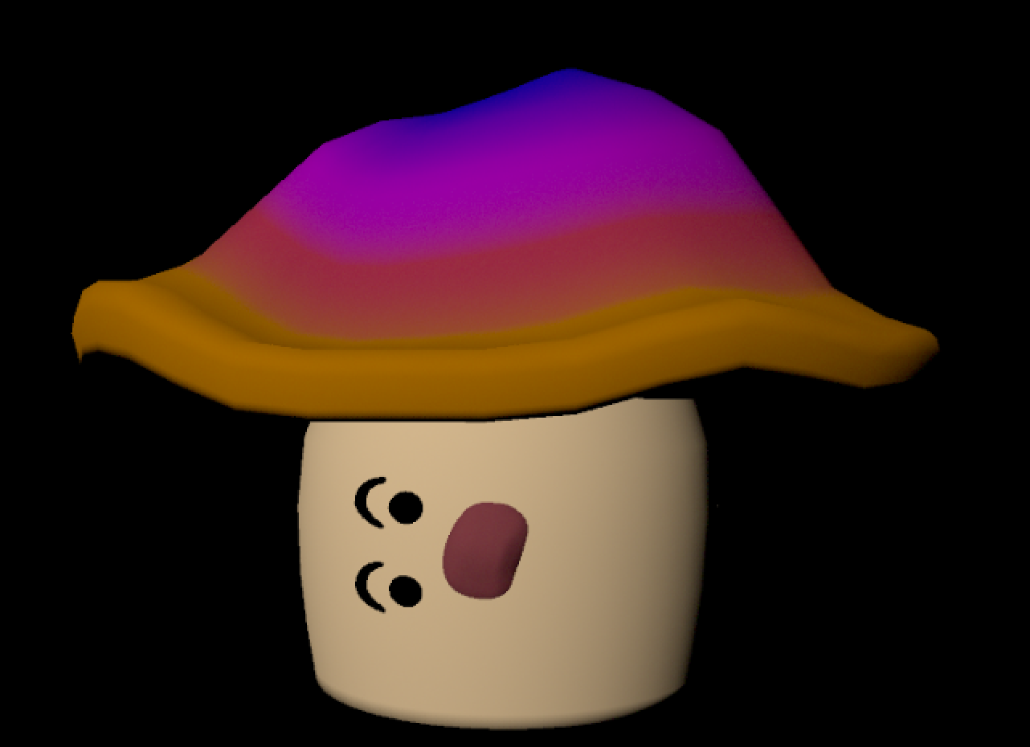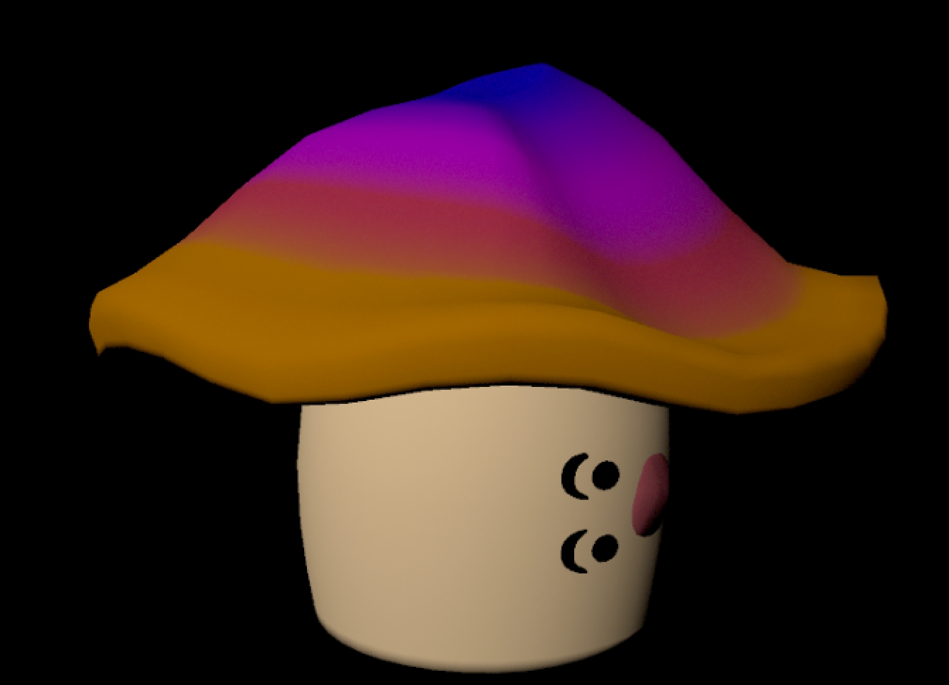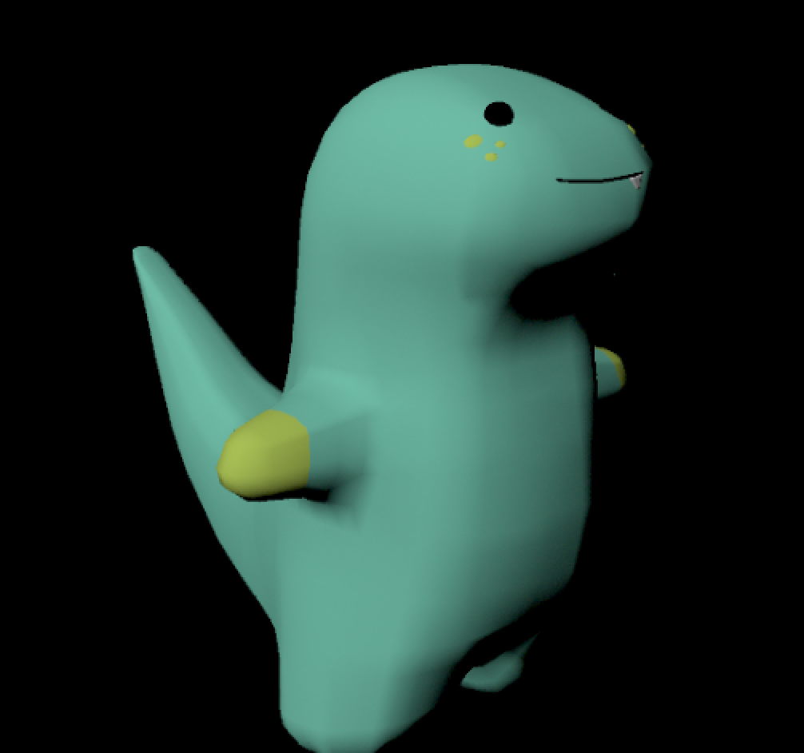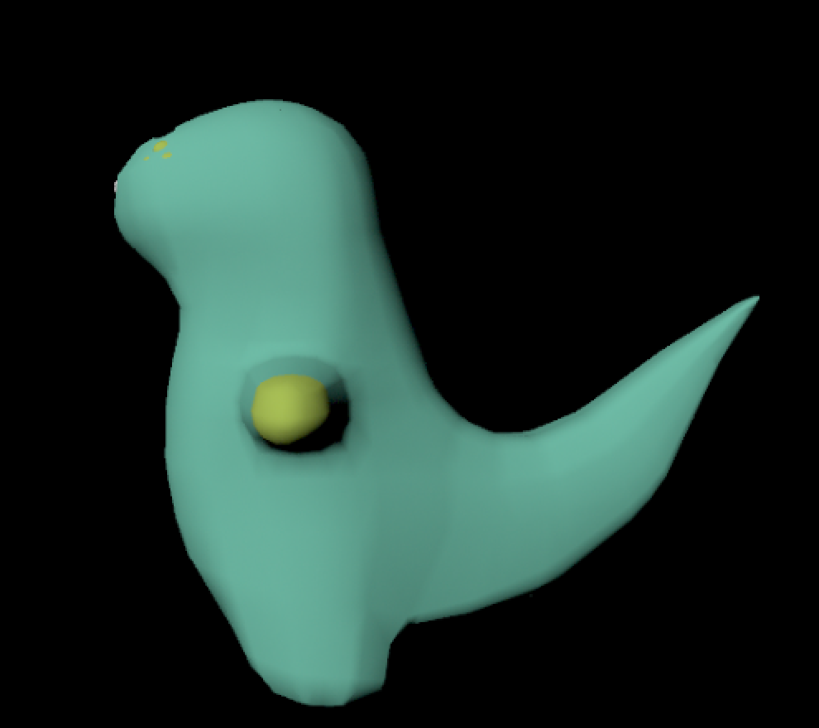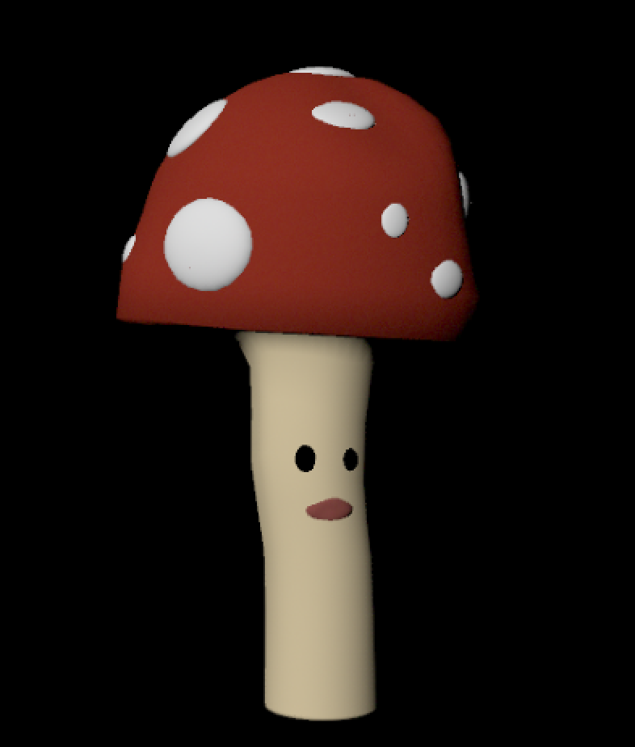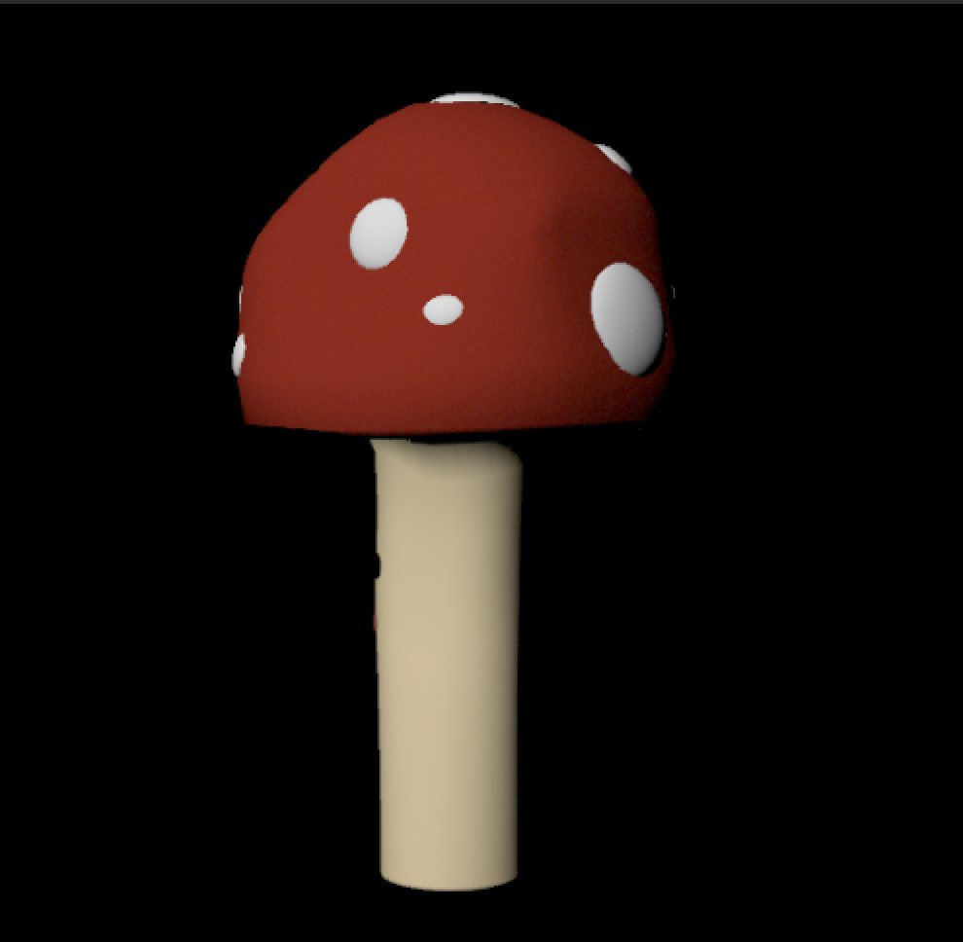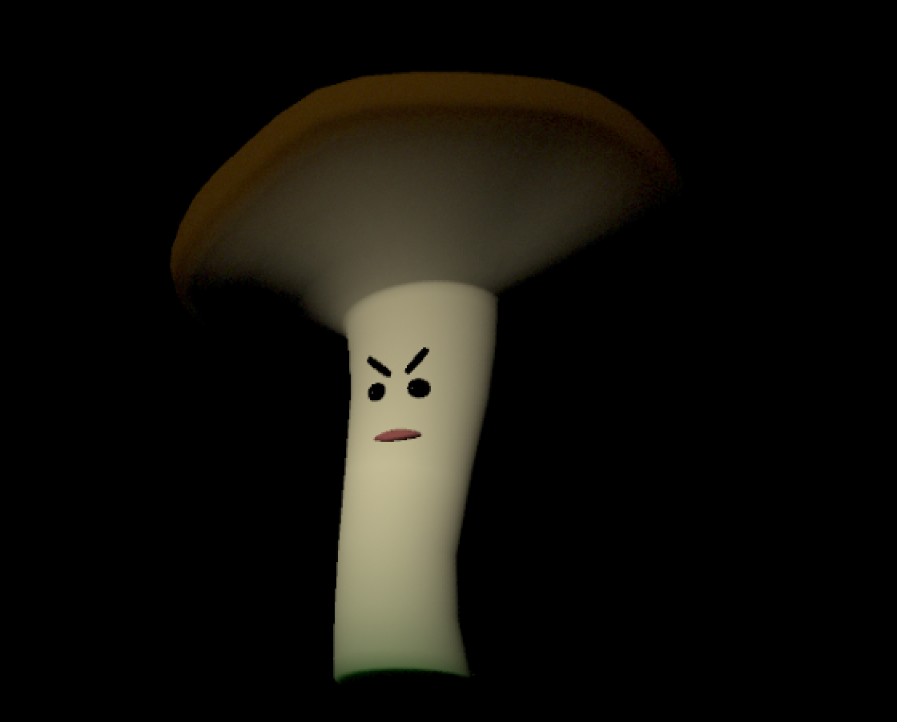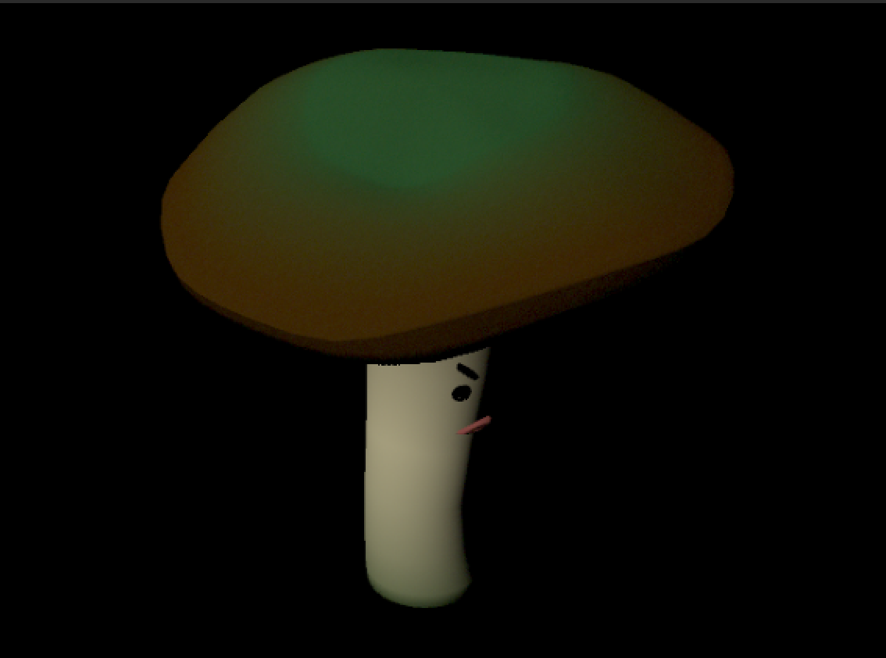

Sound

We used music by Grayland for our concert hall; Grayland is an experimental hip hop producer from Richmond, VA. Ambient noises include field recordings of cave interiors and gameplay sounds inspired by video games from the 80’s and 90’s.